# ACN programming assignment 3

## Part1 Learning Switch and Hub Controller

**Question 1: conducting 3 pings for each case. Report the latency values. Explain the**

**observed latency differences between the Hub Controller and Learning Switch. Also, explain**

**differences (if any) observed between h2 and h5 for both controller types.**

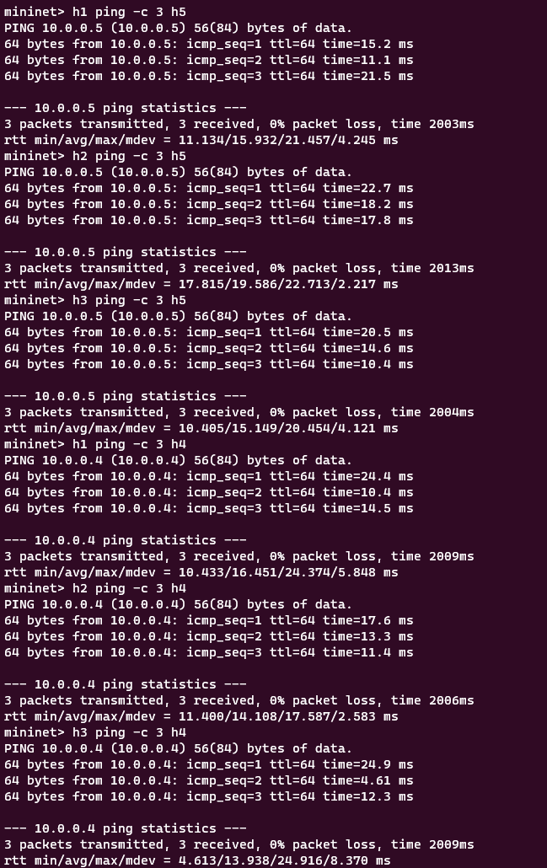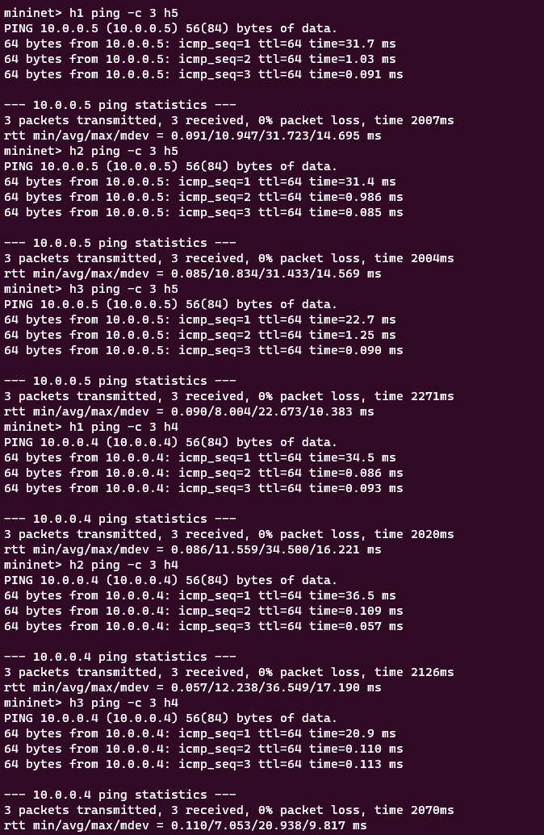

Figure HUB ping results with latency Learning switch ping results with latency

Answer: The learning switch saves port mappings based on the source and destination of packets, allowing it to learn where to send a packet for a given source and destination. This reduces the time it takes to find the destination of packets in subsequent pings, resulting in lower latency values as the number of pings increases.

While using Hub, there is no stored data for mapping source and destination ports of a packet. Therefore, for every ping, the destination address of the packet has to be resolved using ARP signals. This results in increased latency for every subsequent packet, as it does not decrease significantly.

**Question 2: Run a throughput test between h1 and h5. Report the observed values. Explain the differences between the Hub Controller and Learning Switch.**

Throughput between H1 abd H5 in HUB

3 throughput between h1 and H5 in Learning switch

Ans: The difference in throughput between the learning switch and the hub is due to the learning switch storing the port mapping while the hub has to resolve the destination address each time, leading to decreased throughput.

**Question 3 : Run pingall in both cases and report the installed rules on switches**.

Pingall HUB and Switch rules

Pingall Learning switch and rules on learning switches

## ***Part2 Firewall***

**Question1: Run pingall and report the results.**

Ping reachability for every host

Packet drop messages from the Controller

**Question 2 Report the installed rules on both switches. Can you think of ways to minimize the number of firewall rules on the switch**?

8 rules are installed on the switches.

Answer When managing a firewall, it is more efficient to use CIDR notation for IP addresses when creating rules instead of making separate rules for individual IP addresses or services. This will help to better manage the firewall. Group the hosts that need to be blocked together and add a rule for the group instead of creating separate rules for each host.

**Question 3: Suppose the network operator intends to implement firewall policies in real time. How can she ensure that the pre-existing rules do not interfere with the firewall policy?**

Ans: prioritizing the rules: the dynamic rules can be given a lower priority and the preexisting rules higher so that if in case of conflicting rules, the preexisting rules will be implemented, or vice versa.

Keeping track of conflicting rules whenever some conflict arises, so that they can be avoided in the future.

## ***Part3 Load balancer***

**Question1 : Have the three hosts (H1, H2, and H3) ping the virtual IP and report the installed rule on the switches.**

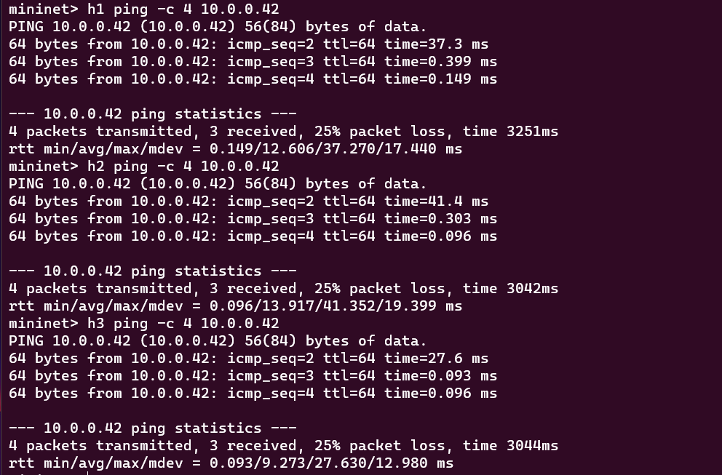

Ping results for h1 , h2 and h3 to virtual IP

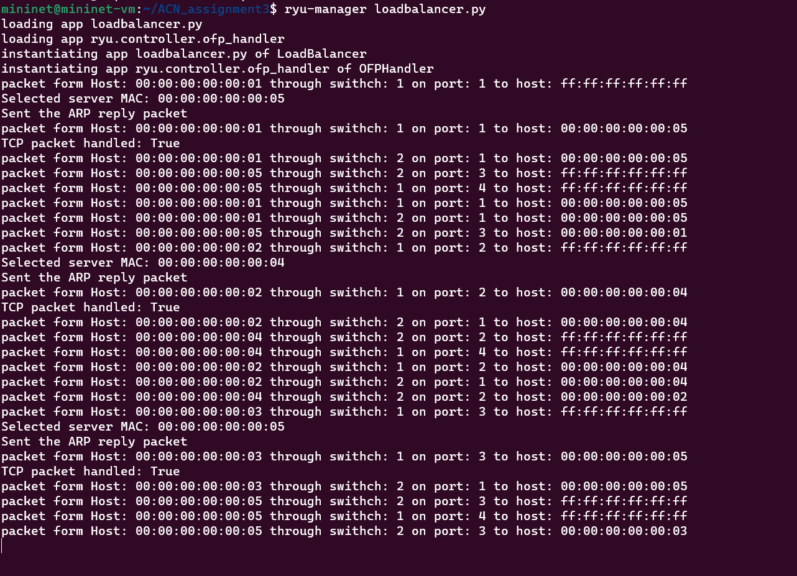

Controller output

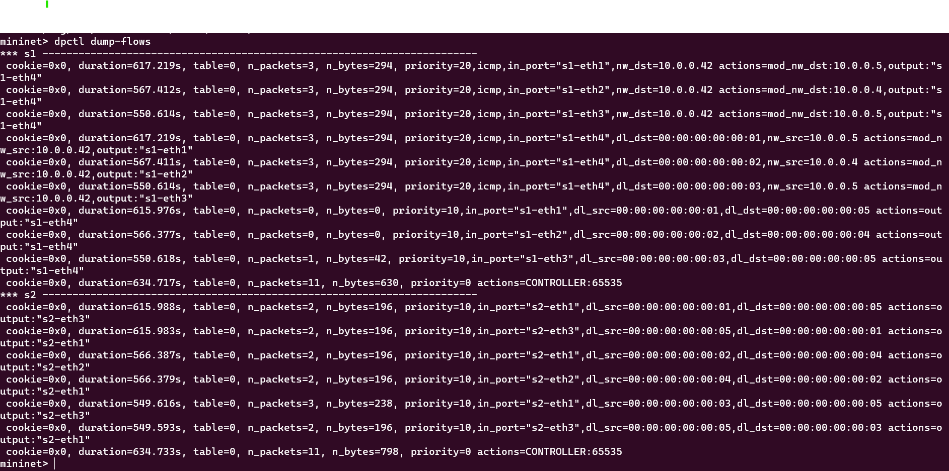

Installed rules

**Question2: If you were to implement a load balancing policy that considers the load on these servers, what additional steps would you take?**

Ans: A load balancer for H4 and H5, we would need a feedback mechanism to monitor server health and performance.

We can periodically check the health of H4 and H5 , If one of the servers becomes overloaded or unresponsive, we can update the flow rules to direct traffic away from that server. If H4 becomes overloaded, we can create a new flow rule to send more traffic to H5 or temporarily remove H4 from the pool until it recovers.

To further optimize the load balancing policy, we can also consider the historical data of server utilization. By analysing the data, we can identify patterns and trends in server usage, which will help us to make informed decisions when adjusting the flow rules.

we can also use geolocation-based load balancing to direct traffic to the servers that are closest to the users. This will help reduce the latency and improve the overall user experience.